April 25, 2012

[**Theater**](http://www.thestranger.com/seattle/Theater)

The Beatles as Teenagers

*HELP* at Seattle Children’s Theatre

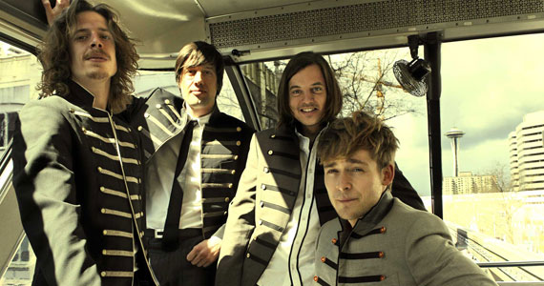

*by* [Catherine R. Smyka](http://www.thestranger.com/seattle/catherine-r-smyka/Author?oid=12734967)



Chris Bennion

**Seattle Children's Theatre**   
Thurs-Fri at 7 pm, Sat at 2 and 5:30 pm, Sun at 11 and 2:30 pm. Through May 13.

Rarely is “Please Mr. Postman” sung as a threnody, but John Lennon hides behind the peppy lyrics to grieve the death of his mother in *HELP* at Seattle Children’s Theatre.

*HELP*, by Dutch theater company Theatergroep Max., examines the hardships that the young John, George, Ringo, and Paul faced during their rise to fame in the late 1950s. The actors give the audience glimpses of what life might have been like for the boys—the arguments a teenage band might have, what financial and family challenges they might face, and how the introduction of foreign things like drugs (and girls!) might affect their relationships and their music. The actors’ emotions feel raw and genuine as each band member endures his own struggles. The best performances in *HELP*, however, come from Lottie Hellingman, who plays their groupie—a squealing teenage girl—as well as John’s mother and other characters. Her roles make sense, and her consistency keeps the show grounded.

Some parts of *HELP* are confusing, as if director Moniek Merkx made a list of every good idea she had and then never settled on one theme, protagonist, or tone. What is real and what’s fantasy? Is that a German stripper in a red rain slicker? Or is that part of an acid trip? If so, whose trip is this? Who is narrating *now*?

Nevertheless, HELP is an innovative family show. According to the Theatergroep Max. website, the group “creates grown-up theatre for everyone who feels young,” and that is exactly what they’ve done with HELP. Instead of parents bringing their kids to be entertained by talking animals or other children’s-theater clichés, HELP is a shared experience, giving younger and older audience members access to four young men before they were the Beatles. Kids and teenagers get a quick pop-culture history lesson and the adults get to indulge in some nostalgia. But more than that, HELP reminds everyone in the audience that being a teenager can be rough, no matter who you are.

<http://www.thestranger.com/seattle/the-beatles-as-teenagers/Content?oid=13462860>