**Review: Holland’s fantastic export – ‘HELP’**

by Miryam Gordon | 04/14/12 |

[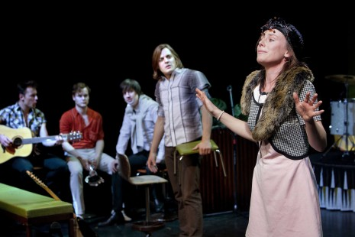](http://culturemob.com/review-hollands-fantastic-export-help/help-3-phile-deprez-2)

[Seattle Children’s Theatre](http://www.sct.org) has scored a big one with the import of [Theatergroep Max’s](http://www.tgmax.nl/english/theatergroep-max-/134/) production of *HELP*, a story of the beginnings of the Beatles. Artistic director Linda Hartzell reports that it took several years of planning with director Moniek Merkx, who had to oversee a translation from Dutch to English.

The production is a fun encapsulation of the very start of how the Beatles got together, from Pete Best and John Lennon’s country music duo to adding George, Paul and eventually replacing Pete with Ringo. The six cast members don’t try to have much of a British accent most of the time, and you don’t really miss it. They also don’t try to look like the Beatles, thankfully, but as far as musical sound and musical talent, boy howdy! do they sound great.

In addition, there is one amazing woman, Lottie Hellingman, who steals the show as multiple female parts, including a young teen early fan who seems to be their first groupie, and several scenes as John’s troubled mother. She also plays piano and sings with the group at times, showing a terrific singing voice. She’s great fun to watch as she wildly dances her enthusiasm, sometimes jumping on the couch because she’s so excited.

SCT bills the show for children aged 11 and up, but opening night there were lots of younger children, most of whom were entranced and appropriately attentive. It’s a pretty sure bet that there will be lots of new Beatles fans among the kids who get to see this show. Though, perhaps it’s best not to bring younger than 8 year olds.

Still, the show is a brisk 70 minutes, with an encore of several famous Beatles tunes. It flies by. There’s not a slow moment in the whole thing. The five talented men are Viktor Griffioen as Pete, Erik van der Horst as George, Marne Miesen as Paul, Matthijs van de Sande Bakhuyzen as John and Mees van Warmerdam as Ringo.

Have your family *Come Together* from *Here, There, and Everywhere* and *It Won’t Be Long* before you all *Twist and Shout* about this terrific show.